CERTIFICATE OF AUTHORSHIP

We hereby certify that this submission, CS179.14 Final Project abides by the principles stipulated in the DISCS’ Academic Integrity Policy document. We further certify that we are the authors of this program/ project/ report/ paper and that any assistance we received in its preparation is fully acknowledged and disclosed in the documentation. We have also cited all sources from which we obtained data, ideas, or words that are directly copied or paraphrased in this document. Sources are properly credited according to accepted standards for professional publication.
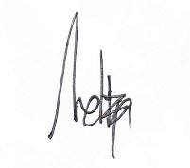

Meliza De La Paz

Fauxtin Marques

Submitted to: Sir Wilhansen Li
Date of Submission: March 27, 2015
As required in: CS 179.14 – PC/Console Development

Sources:

http://www.reddit.com/r/gamedev/comments/13y26t/how_do_rhythm_games_stay_in_sync_with_the_music/
http://www.reddit.com/r/gamedev/comments/2fxvk4/heres_a_quick_and_dirty_guide_i_just_wrote_how_to/
http://www.dreamincode.net/forums/topic/185301-playing-audio-files-with-irrklang/
http://www.cplusplus.com/reference/random/subtract_with_carry_engine/
http://www.cplusplus.com/reference/functional/hash/

